Hospital Management System

2023

OOP project ’ 23 | BSSE-2A

Imama kainat 22F-3661

noor fatima 22f-3634

Zainab Eman 22F-3738

**Hospital Management System**

The hospital management system developed using C++ is a computer-based application designed to streamline the hospital's administrative tasks. The system allows hospital staff to manage patient records, schedule appointments, manage billing, and track inventory.

The system comprises following main modules:

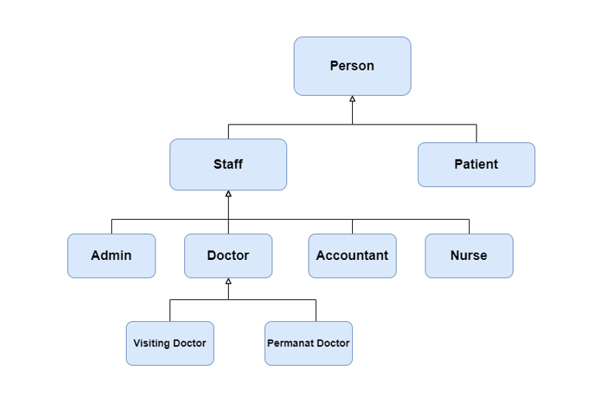

Detail of each data members and member function of each class and module is shown in class diagram below:

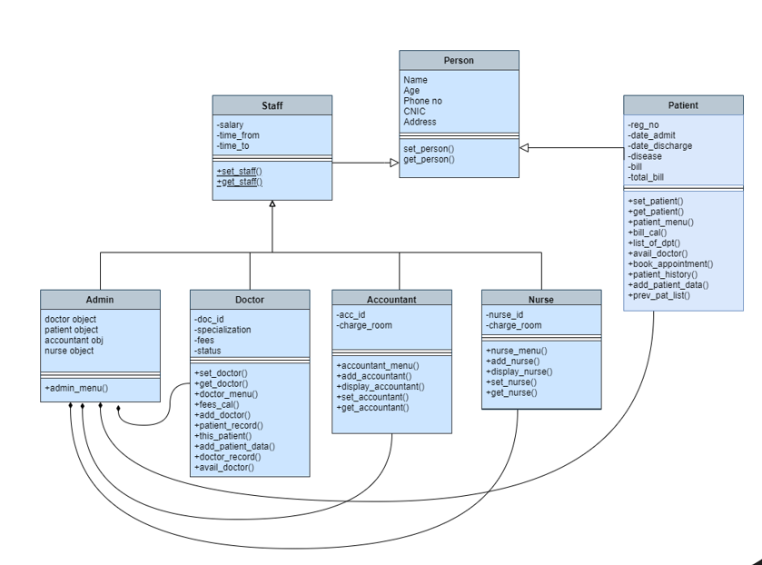

* Arrow sign show inheritance
* Diamond sign show composition

OOP concepts used:

* Classes
* Parametrized and default constructor
* Hierarchical Inheritance
* Polymerization
* Composition
* Static constant integer
* Exception handling
* File handling

Overall, the Hospital Management System developed using C++ is an efficient and reliable solution for managing hospital administrative tasks. It improves hospital operations by providing a streamlined process for managing doctors record, departments record, accountant’s records, nurse record, patient records, appointments, billing, and inventory.